**Activity diagram**

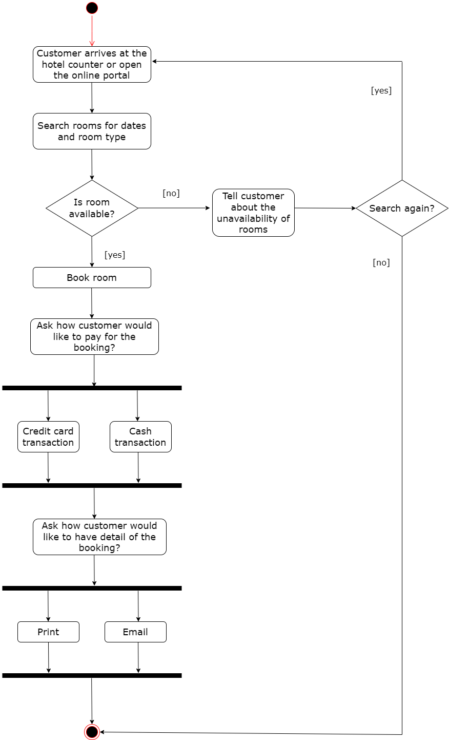

Figure 2.1 Activity diagram for room booking

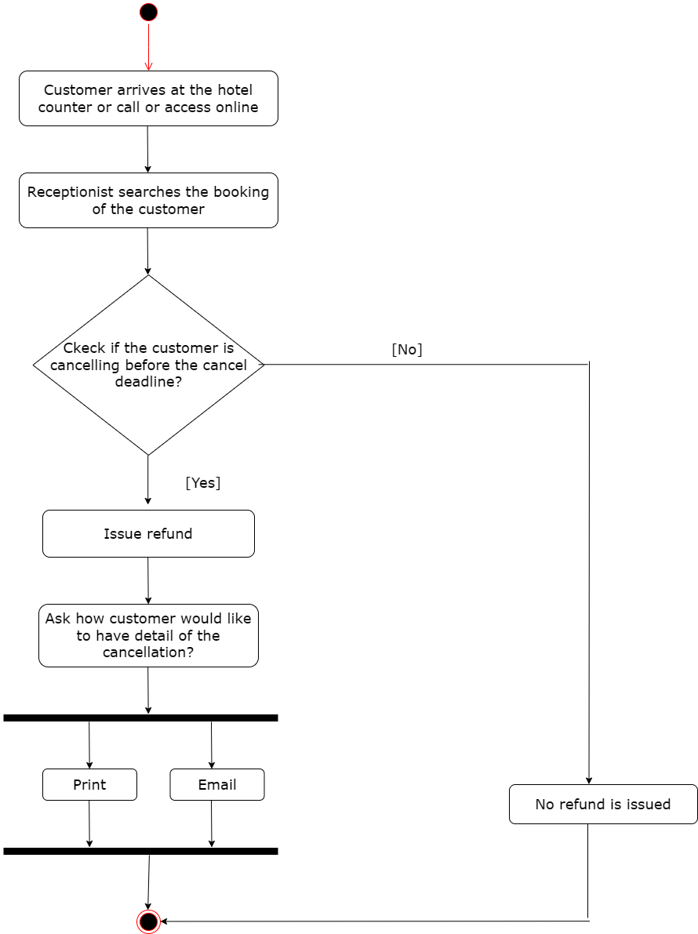

Figure 2.2 Activity diagram for cancel a booking